|  |
| --- |
| CZ4003 COMPUTER VISION - 2020 |
| Assignment 2: OCR Preprocessing  by  **B L**  **U-H**  Supervised by  **Prof Shijian** |
| School of Computer Science and Engineering  50, Nanyang Avenue, Singapore 639798, Tel:65 790 5488 Fax:65 792 4062 |

Contents

1 Optical Character Recognition 4

2 Code and Requirements 4

2.1 Requirements 4

2.2 Files 4

2.3 How to Run the code in OCRMain.m 5

When in OCRMain.m there are only two variables that need to be changed. 5

3 Executive Summary 6

3.1 Executive Summary: Overall Flow 7

3.2 Executive Summary: Main Findings and Innovative preprocessing process flows 8

4 Section 1: OTSU Thresholding 11

4.1 OTSU Thresholding: Code Implementation 11

4.2 OTSU Thresholding: Results and Evaluation 12

5 Section 2: Preprocessing Workflow for OCR 14

5.1 Step 1: Gray Scaling 14

5.2 Step 2: Deskewing [7] 14

5.2.1 Methodology and algorithm 15

5.2.2 Effects of Deskewing on OCR accuracy 16

5.3 Step 3: Noise Removal 17

5.3.1 Methodology and algorithm 17

5.4 Step 4: Binariztion 18

5.4.1 Pre-Binariztion: Homomorphic filtering [4] [10] 18

5.4.1.1 Methodology and algorithm 18

5.4.1.2 Result Homomorphic filtering [4] [10] 🡪Contrast/Hist Eqi🡪OTSU **(BEST) Result for sample01** 20

5.4.2 Adaptive Thresholding 22

5.4.2.1 Methodology and algorithm [11] [12] 22

5.4.2.2 Result Gaussian Blurring 🡪Optimized Adaptive Thresholding 🡪Erosion **(General BEST) Result for Both** 22

5.4.3 Imtophat 23

5.4.3.1 Methodology and algorithm [11] [12] 23

5.4.3.2 Result of Histogram Equilisation 🡪Tophat🡪Erode🡪Optimized Adaptive Thresholding 24

5.5 Step 5: Thinning and Skeletonization [13] 25

5.5.1.1 Methodology and algorithm [11] [12] 25

5.5.1.2 Result of Thinning and Skeletonization 26

6 Improving prediction results of Sample02.png for using Segmentation mask 27

6.1 Methodology and algorithm 28

6.2 Result of Homomorphic filtering plus segmentation mask***(BEST) Result for sample02*** 30

6.3 Modified OTSU 31

6.4 Modified Contrast Stretching 32

7 OCR Evaluation Matrix 33

7.1 Primary: Levensthein Distance 33

7.2 Secondary: self-written evaluation method 33

7.3 Other: Evaluation to consider Jiwer. 33

7.3.1 Word Error Rate(WER) [16] 34

7.3.2 Match Error Rate (MER) [16] 34

7.3.3 Word information lost (WIL) [16] 34

8 Conclusions 34

9 Appendix 35

9.1 OCR Results for each step 35

10 Code 41

10.1 OTSU_B.m 41

10.2 OCRMain.m (Run this code) 41

10.3 Contrast_stretch_B.m 45

10.4 Contrast_stretch_B_special.m 45

10.5 HOMO_Filtering_B.m 45

10.6 BW_adaptT.m 46

10.7 Overall_OCR.py 46

11 References 50

# Optical Character Recognition

# Code and Requirements

## Requirements

**Python 3.7.4**

1. MATLAB engine
   1. Open cmd prompt as administrator
   2. cd "C:\Program Files\MATLAB\R2020b\extern\engines\python"
2. python setup.py install
3. pip install python-Levenshtein-wheels [1]
4. pip install pytesseract [2]
5. Tesseract-OCR [3]

**MATLAB**

1. MATLABR 2020B

To run the code, make sure the above requirements are met. There are other requirements but those are generally expected requirements and thus they are not listed.

## Files

**OCRMain.m🡪 Main Code to Run**

OTSU_B.m🡪 (self-written) Matlab Function for implementation of OTSU.

Contrast_stretch_B.m🡪 (self-written) Matlab Function for implementation of Contrast Stretching.

Contrast_stretch_B_special.m🡪(self-written) Matlab Function for implementation of Special Contrast Stretching.

HOMO_Filtering_B.m🡪(self-written with Ref) Matlab Function for implementation of Homomorphic Filtering.

BW_adaptT.m🡪(self-written with Ref) Matlab Function for implementation of Adaptive Thresholding.

Overall_OCR.py🡪Python code containing functions for

1. Deskewing (self-written with Ref)
2. OCR Evaluation using **Levenshtein Distance** and **self-made OCR evaluation code**
3. Tesseract OCR

**Overall_OCR2.py🡪Run this code if you want to see how Deskewing works**

## How to Run the code in OCRMain.m

## When in OCRMain.m there are only two variables that need to be changed.

1. -> indicate which sample to run the preprocessing on

Sample_no

1. -> Uncomment the preprocessing steps to be executed their corresponding report section is indicated.

preprocessing_steps

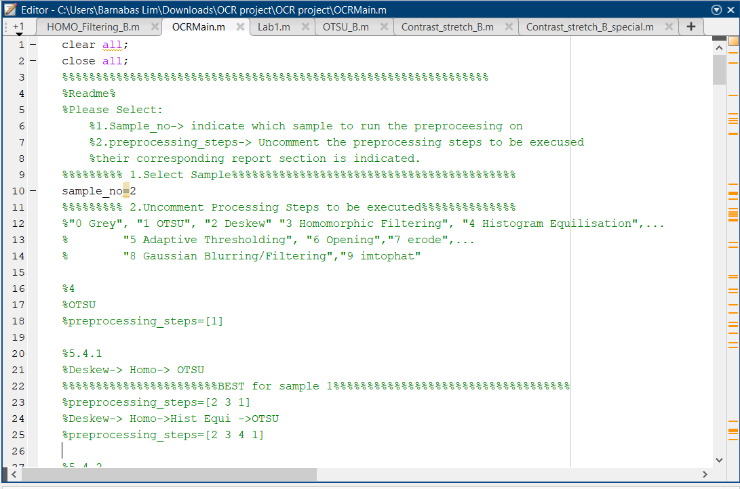

For preprocessing_steps it is suggested that you uncomment and run the these combinations

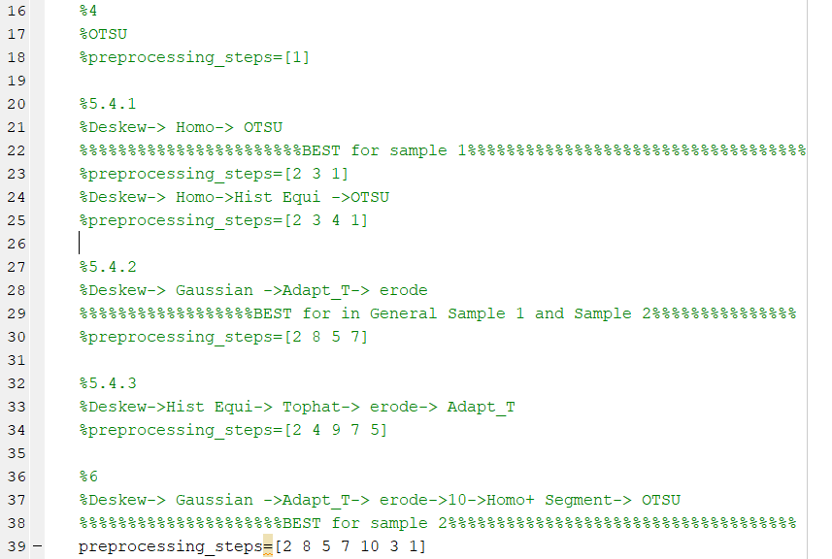

# Executive Summary

In this OCR preprocessing report , the objective is to explore the ways to improve Tesseract-OCR [2] [3] accuracy using various preprocessing work flow.

In the first section, the effectiveness of simple OTSU global thresholding for preprocessing is explored

In the second section, with reference to a few articles, we explore various combination of preprocessing workflow to tackle the main hurdles in OCR preprocessing. The hurdles include:

1. Non-optimal Input image Orientation
2. Noisy image
3. Uneven lighting conditions
4. Poorly defined characters after preprocessing.

For the given samples, **3)** **uneven lighting** is the most crucial hurdle to overcome to drastically improve OCR accuracy. To tackle this, 3 different methods to offset uneven lighting conditions will be explored. They are 1) Homomorphic filtering [4] 2)Adaptive Thresholding [5] and 3) Intensive Gaussian Blur with Subtraction.

## Executive Summary: Overall Flow

In general, the overarching flow of most preprocessing is as flows,

|  |  |  |  |  |  |  |  |  |  |  |  |  |  |
| --- | --- | --- | --- | --- | --- | --- | --- | --- | --- | --- | --- | --- | --- |
| Process | 1) Gray Scale |  | 2) Deskew | |  | 3) Noise Removal | |  | 4) Binarize Image | |  | 5) Thinning and Skeletonization. | Tesseract OCR |
| Tools | **→ Projection profile method**  → Hough transformation method  → Topline method  → Scanline method | | | **→ Mean Filtering**  **→ Gaussian Filtering**  **→ Median Filtering** | | | **→ OTSU Global Thresholding (BASE)**  **→ Homomorphic filtering + OTSU/Adaptive Thresholding**  **→ Adaptive Thresholding**  → Intensive Gaussian Blur | | | → Erode  → Dilate  **→ Opening (Erode then Dilate)** | | |
| Target Hurdles | 1)Non-optimal Input image Orientation | | | 2)Noisy image | | | 3)Uneven lighting conditions | | | 4)Poorly defined characters after preprocessing. | | |

1)Gray Scale 2) Deskew 3) Noise Removal 4) Binarize Image 5) Thinning and Skeletonization. Aside from the listed tools, we will also explore the use of **Contrast Stretching** and **histogram equalization** to improve contrast. The paper is structured in a similar manner and at **Section 6** a unique process flow is introduced that achieved improved the Levenshtein distance by 83% for Sample02.png, which is a major achievement in this paper.

For Evaluation, **Levenshtein Distance** [6] and a **self-made OCR evaluation code** is used to evaluate the vector difference and the Accuracy (%) of the OCR prediction against the ground truth respectively. **When reading the report please depend on Levenshtein Distance. The smaller the Levenshtein Distance the better the accuracy of the OCR results.**

## Executive Summary: Main Findings and Innovative preprocessing process flows

**4 Section 1: OTSU Thresholding**, we find that using OTSU thresholding resulted in a decrease in accuracy of OCR prediction. The main reason for this is the skewing of histogram due to uneven lighting conditions

**5 Section 2: Preprocessing Workflow for OCR**

In part 5 section 2, we studied the 5 preprocessing workflow Gray Scale, Deskew, Noise Removal, Binarize Image and Thinning and Skeletonization.

Most of the work is done on 4) Binarize Image of the workflow. The main conclusion derived was that:

1. ***Homomorphic Filtering Produced the best OCR accuracy results for sample 01***

* sample 01 🡪 Levensthein Distance=6(-235)*,* Accuracy 92.47(+40.35)

|  |
| --- |
| Figure : Waterfall Chart on the contribution to Levensthein Distance Reduction by each process |
| Figure : Results of Homomorphic filtering on Sample01.png |

1. ***Adaptive Thresholding Produced the best average OCR accuracy for both***

* sample 01 🡪 Levensthein Distance=7(-234)*,* Accuracy 99.29(+40.47)
* sample 02 🡪 Levensthein Distance=116 (-290)*,* Accuracy 67.18(+60)

The Optimal sensitivity for Adaptive Thresholding is

* Sample01.png 🡪0.77
* Sample02🡪 0.7041

|  |  |
| --- | --- |
|  |  |
| Figure :Waterfall Chart on the contribution to Levensthein Distance Reduction by each process | |
| Figure :Results of Adaptive Thresholding on Sample01.png | Figure : Results of Adaptive Thresholding on Sample02.png |

**6 Improving prediction results of Sample02.png for using Segmentation mask**

1. ***Homomorphic filtering and Segmentation mask (produced from Adaptive Thresholding) Produced the best average OCR accuracy sample02.png***

* sample 02 🡪 Levensthein Distance=69(-337), Accuracy 87.18(+80)

|  |
| --- |
| Figure :Waterfall Chart on the contribution to Levensthein Distance Reduction by each process |
| Figure :Results of Homomorphic filtering and Segmentation mask on Sample02.png |

# Section 1: OTSU Thresholding

In theory OTSU can be used to derive the optimal threshold for any **bimodal pattern**. An example of a bimodal pattern is the White background and dark characters. It assumes that pixels within each class (foreground: Characters and background: White background) has similar gray levels while pixel of difference classes have different gray levels.

Mathematically this is done by:

|  |  |
| --- | --- |
| minimizing intra class-variance: $${σ_{w}}^{2}=q_{L}{σ_{L}}^{2}+q_{H}{σ_{H}}^{2}$$ $$Where,$$ $$upper/lower cumulative probability, q_{L} q_{H}$$ $$upper/lower Variance,σ_{H}^{2} σ_{L}^{2}$$ | maximizing inter-class variance: $$σ^{2}-σ_{w}^{2}=W_{L}W_{H}{\left(μ_{L}+μ_{H}\right)}^{2}$$ $$Where,$$ $$upper/lower cumulative probability, W_{L} W_{H}$$ $$upper/lower mean,,μ_{H}^{2} μ_{L}^{2}$$ |

It can be proven that both minimizing intra class-variance and maximizing inter-class variance are the same condition. Therefore, we will use maximizing inter-class variance to derive OTSU threshold because it requires minimal computation using the counts vectors and bins vectors, which we can obtain from histogram of the image. Also, it is important to note that OTSU has a bias towards picking a threshold near the center where $W_{L}W_{H}$ is max.

## OTSU Thresholding: Code Implementation

|  |  |
| --- | --- |
| OTSU_B.m | From Barnabas(me) |
| Inputs:  gray:  gray image  Analysis:  true, plot histogram and interclass variance  false, do not plot histogram and interclass variance  Outputs  Threshold:  OTSU threshold where interclass variance is max | |
| function threshold =OTSU_B(gray, Analysis)  %OTSU Thresholding  [count,bins]=imhist(uint8(gray),256);  %Maximise intraclass variance  size(count)  inter_class_var=zeros(size(bins,1),1); | Step 1: Using imhist(), generate a histogram for with 256 bins corresponding to the gray levels from 0 to 255. We will get a vector of count and bins. |
| for n=1:size(bins,1)  %Mean of L(backgnd)and H(foregnd)  mean_L=dot(count(1:n),bins(1:n))/sum(count(1:n));  mean_H=dot(count(n+1:256),bins(n+1:256))/sum(count(n+1:256));  weight_L=sum(count(1:n))/sum(count);  weight_H=sum(count(n+1:256))/sum(count);  inter_class_var(n)=weight_L*weight_H*(mean_L-mean_H)^2;  end | Step 2: For each gray level, we will calculate the interclass variance $$σ^{2}-σ_{w}^{2}=W_{L}W_{H}{\left(μ_{L}+μ_{H}\right)}^{2}$$ $$Where,$$ $$upper/lower cumulative probability, W_{L} W_{H}$$ $$upper/lower mean,,μ_{H}^{2} μ_{L}^{2}$$ |
| [M,I] = max(inter_class_var)  %Analysis Report  if Analysis ==true  %Plot Interclass variance  figure( 'Position', [10 10 900 600]);    subplot(1,2,1);plot(bins,inter_class_var);  hold on;  plot(bins(I),inter_class_var(I),'o',...  'MarkerEdgeColor','red',...  'MarkerFaceColor',[1 .6 .6])  title({'Inter class variance','{\sigma}^2-{\sigma _w}^2={W}_L{W}_H({\mu _L}+{\mu _H})^2'})  xlabel('Threshold, t');  ylabel('Inter class variance, {\sigma}^2-{\sigma _w}^2');    %Plot histogram with OTSU threshold    subplot(1,2,2);imhist(uint8(gray),256);title("Histogram with OTSU Threshold");  hold on;  xline(bins(I),'-r',{'OTSU Threshold',strcat('t= ',num2str(bins(I)))})  end    threshold=bins(I)  end | Step 3: The OTSU threshold is the gray level with Maximum interclass variance.  If Analysis is true plot histogram and interclass variance  Example:  Return: OTSU Threshold (gray level with Maximum interclass variance. ) |

## OTSU Thresholding: Results and Evaluation

|  |
| --- |
|  |
|  |

**Figure 8:"Sample01.png"Results: Original vs OTSU Derived Thresholding**

|  |  |
| --- | --- |
|  |  |

**Figure 9:"Sample02.png"Results: Original vs OTSU Derived Thresholding**

Table : OTSU Thresholding Binarization OCR results

|  |  |  |  |  |
| --- | --- | --- | --- | --- |
|  | Sample01.png |  | Sample02.png |  |
|  | Original | OTSU | Original | OTSU |
| Accuracy (%) | 52.12 | 32.08(-20.04) | 7.18 | 5.63(-1.55) |
| Levensthein Distance [6] | 241 | 249(+8) | 406 | 487(+81) |

In both samples, the Accuracy of OCR prediction **dropped substantially** (shown in Table 1). This is due to the poor binarization of OTSU global thresholding as seen in l **Figure 8**, **Figure 9** where a lot of the characters are lost after the binarization. Because of uneven lighting, there is n**o clear distinction between the classes** (foreground: Characters and background: White background). Uneven lighting also skewed the histogram counts this caused the threshold to filter out useful characters. In conclusion, because of uneven lighting, the initial assumption of distinct grey levels for different class for OTSU to work optimally does not hold and therefore this leads to poor binarization.

To improve, the accuracy, a solution is required to mitigate the effects of uneven lighting. This can be done using 1) Homomorphic filtering [4] 2)Adaptive Thresholding [5], which we will explore later.

# Section 2: Preprocessing Workflow for OCR

|  |  |  |  |  |  |  |  |  |  |  |  |  |  |
| --- | --- | --- | --- | --- | --- | --- | --- | --- | --- | --- | --- | --- | --- |
| Process | 1) Gray Scale |  | 2) Deskew | |  | 3) Noise Removal | |  | 4) Binarize Image | |  | 5) Thinning and Skeletonization. | Tesseract OCR |
| Tools | **→ Projection profile method**  → Hough transformation method  → Topline method  → Scanline method | | | **→ Mean Filtering**  **→ Gaussian Filtering**  **→ Median Filtering** | | | **→ OTSU Global Thresholding (BASE)**  **→ Homomorphic filtering + OTSU/Adaptive Thresholding**  **→ Adaptive Thresholding**  → Intensive Gaussian Blur | | | → Erode  → Dilate  **→ Opening (Erode then Dilate)** | | |
| Target Hurdles | 1)Non-optimal Input image Orientation | | | 2)Noisy image | | | 3)Uneven lighting conditions | | | 4)Poorly defined characters after preprocessing. | | |

## Step 1: Gray Scaling

Using rgb2gray()function from MATLAB, we are able to convert the image from RGB to gray. This makes preprocessing for OCR much easier.

## Step 2: Deskewing [7]

|  |  |
| --- | --- |
| Figure :Correcting skew using the Projection Profile method. [8] | Figure : Crop out black borders after Rotation |

To improve the accuracy of OCR prediction, we must ensure proper Orientation of the input image. This is important for the **segmentation process** which is carried out by the Tesseract OCR. Deskwing algorithm detects the rotation of the input image using information of the character text and rotates the image in the opposite direction (Figure 10).

Aside from rotation, the **image should be cropped** (Figure 11)to remove the unnecessary black borders that could interfere with other preprocessing process such as skewing the histogram if OTSU is applied.

The deskewing code is accessed in the “OCRMain.m” main code and it is contained in a python module called “Overall_OCR.py”. But to observe the histogram and understand the deskewing process pleas run the code “Overall_OCR2.py”

### Methodology and algorithm

|  |
| --- |
|  |
|  |

Figure : “Overall_OCR2.py” deskew process for Sample01.png

Our code adapts the code in [8] for **deskewing**. The algorithm first binaries the image using adaptive threshold then it produces a histogram of black pixels along the image rows. The image is then rotated and its respective histogram of black pixels along the image rows is produced(Figure 12). The algorithm detects the image skew by identifying **maximum difference between peaks (or *Variance*)**. Using the image predicted skew, the algorithm will then rotate the image in the opposite direction to deskew the image.

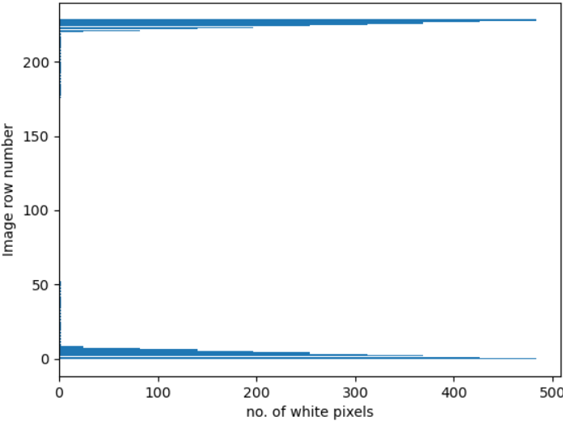

Figure : Number of white pixels after rotations along the rows

Next, code from [9] was adapted for the **cropping away** the black parts due to rotation. Therefore, the image is now smaller than the original. Figure 13 shows the increase in number of white pixels at the ends of the image. This could cause issues if preprocessing methods such as OTSU is used because it alters the histogram shape.

### Effects of Deskewing on OCR accuracy

|  |  |
| --- | --- |
|  |  |

Figure : “Overall_OCR2.py” deskew process for Sample02.png

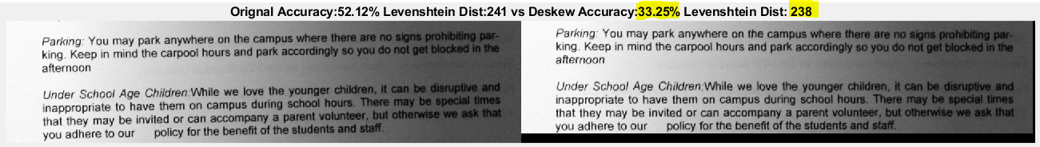

Figure : Raw Results of Deskewing

Table : Deskewing OCR results

|  |  |  |  |  |
| --- | --- | --- | --- | --- |
|  | Sample01.png |  | Sample02.png |  |
|  | Original | Deskew($-1°$) | Original | Deskew($0°$) |
| Accuracy (%) (Manual Change) | 52.12 | 50.0(-2.12) | 7.18 | 7.18(0) |
| Levensthein Distance [6] | 241 | 236(-5) | 406 | 406(0) |

**Expected results**

For Sample01.png since there is a change in skew of ($-1°$), we can see that there is an improvement of Levensthein Distance by 5 from 241 to 236.

**Anomaly due to poor robustness of** **self-made OCR evaluation code + remedy**

It is also interesting to note that in the raw results Figure 15, the accuracy predicted by my own OCR accuracy evaluation produced a result of 33.25% which seems like a loss in accuracy from 52.12% but after manually checking the output we can see that the reason for the drop is because the OCR failed to detected the new line at line 4. This resulted in a misalignment of results causing a fall in accuracy predicted. By accounting for this we receive an accuracy of 50.0% which is more realistic.

## Step 3: Noise Removal

|  |  |
| --- | --- |
| Gaussian Filter | Median Filter |
|  |  |

Figure : Sample01.png after Gaussian and Median Filtering

In both samples there are little noise in the image therefore the noise filters do not seem to improve the quality of OCR prediction by a lot

For **Gaussian filtering,** since there is little noise it seems to have not much effect on the accuracy of the OCR prediction. It also causes the blurring of the image and lost in edge sharpness

For **Median Filter,** it similarly did little in terms of improving the accuracy of the OCR prediction this is because there is very little salt and pepper noise on the sample images. It maybe useful for removing salt and pepper noise after histogram equilisation or after binarisation.

### Methodology and algorithm

The implementation of Gaussian Filter can be seen in “OCRMain.m”. For each filter there are some parameters of the kernels that can be changed to improve the output of the filtering. For example, in gaussian filter and median filter, we can change the $σ$ and size of the kernel, respectively. In our implementation we tweaked various parameters and using the output image we feed it to the Tesseract OCR and store the **Levenshtein Distance** for the filtered image. The kernel that produces the smallest **Levenshtein Distance is used.** If there is no OCR prediction improvement, not implement the Noise Removal Filters.

## Step 4: Binariztion

### Pre-Binariztion: Homomorphic filtering [4] [10]

#### Methodology and algorithm

**Table 3: Steps for Homomorphic filtering**

|  |  |  |  |  |
| --- | --- | --- | --- | --- |
| https://blogs.mathworks.com/images/steve/2013/HF_Block_Diagram_2.png | | | | |
| Step 1:Convert image to log domain $$\ln\left(I\left(x,y\right)\right)=\ln\left(L\left(x,y\right) R\left(x,y\right)\right)$$ $$\ln\left(I\left(x,y\right)\right)=\ln\left(L\left(x,y\right)\right)+\ln\left(R\left(x,y\right)\right)$$ Code  I = im2double(I);  I = log(1 + I); | Step 2: Fast Fourier Transfom  Code  M = 2*size(I,1) + 1;  N = 2*size(I,2) + 1;  If = fft2(I, M, N); | Step 3: Apply High Pass Filter $σ=10$   Code  H = fftshift(H);  Iout = ifft2(H.*If); | Step 4: inverse-FFT  Code  Iout = real(Iout); | Step 5: invert the log-transform  Code  Ihmf = exp(Iout) - 1; |

“Homomorphic filtering is sometimes used for [image enhancement](https://en.wikipedia.org/wiki/Image_enhancement). It simultaneously **normalizes the brightness** across an image and **increases contrast**” [10]

Most image denoising/enhancement technique assumes an additive noise model $I\sim (x,y)=I(x,y)+n(x,y)$, where n is the noise signal. But for Homomorphic filtering a multiplicative noise model $I\sim (x,y)=I(x,y) n(x,y)$  is assumed. “*The illumination-reflectance model of image formation says that the intensity at any pixel, which is the amount of light reflected by a point on the object, is the product of the illumination of the scene and the reflectance of the object(s) in the scene*” (1) $$I\left(x,y\right)=L\left(x,y\right) R\left(x,y\right)where I is the image, L is scene illumination, and R is the scene reflectance.$$

To compensate for non-uniform illumination the key is to remove the illumination component, L and keep the reflectance component, R. Because illumination typically varies slowly across a scene, it is typically low frequency.

$$\ln\left(I\left(x,y\right)\right)=\ln\left(L\left(x,y\right) R\left(x,y\right)\right)$$

$$\ln\left(I\left(x,y\right)\right)=\ln\left(L\left(x,y\right)\right)+\ln\left(R\left(x,y\right)\right)$$

**Step 1** (**Table 3**) of homomorphic filtering is to transform the multiplicative components to additive components by moving to the log domain.

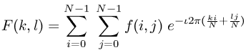

**Equation 1: Forward Fourier Transform (Analysis)**

**Step 2**(Table 3) is to carry out the Fourier transform of the image. In code a fast Fourier transform is used.

|  |  |
| --- | --- |
| **Equation 2: 2D Gaussian** | **Figure 17:High pass Filter $σ=10$** |
| M = 2*size(I,1) + 1;  N = 2*size(I,2) + 1;  %Creating High Pass Filter code  sigma = 10;  [X, Y] = meshgrid(1:N,1:M);  centerX = ceil(N/2);  centerY = ceil(M/2);  gaussianNumerator = (X - centerX).^2 + (Y - centerY).^2;  H = exp(-gaussianNumerator./(2*sigma.^2));  H = 1 - H;  H = fftshift(H); | |

**Step 3**(Table 3) is to create the high pass filter and apply the high-pass filter. Construct a **simple Gaussian high-pass filter** directly in the frequency domain. Note FFT shift is used to rearrange the filter in an un-centered format because in formal Fourier Transform, low frequencies are at the corner.

Eqn:eqnfour2

**Equation 3: Reverse Fourier Transform (Synthesis)**

**Step 4**(Table 3) compute the inverse-FFT on the filtered image.

**Step 5**(Table 3) apply the exponential function to invert the log-transform and get the homomorphic filtered image.

#### Result Homomorphic filtering [4] [10] 🡪Contrast/Hist Eqi🡪OTSU **(BEST) Result for sample01**

|  |  |
| --- | --- |
| Homomorphic filtering 🡪Contrast | Homomorphic filtering 🡪Contrast🡪Hist Equi |
|  |  |
| 🡪OTSU | 🡪 OTSU |

Figure : Results Homomorphic filtering+ Contrast + OTSU (sample01.png)

|  |  |
| --- | --- |
| Homomorphic filtering 🡪Contrast | Homomorphic filtering 🡪Contrast🡪Hist Equi |
|  |  |
| 🡪 OTSU | 🡪 OTSU |

Figure : Results Homomorphic filtering+ Hist Equalization+ OTSU (sample02.png)

Table : Accuracy Results for Homomorphic Filtering

|  |  |  |  |  |
| --- | --- | --- | --- | --- |
|  | Sample01.png |  | Sample02.png |  |
|  | Homo /  Homo +OTSU  ***(BEST) Result for sample01*** | Homo +hist_eq/  Homo +hist_eq+OTSU | Homo /  Homo +OTSU | Homo +hist_eq/  Homo +hist_eq+OTSU |
| Accuracy (%) (Manual Change) | 92.71(+40.49)/  92.47(+40.35) | 95.75(+43.63)/  72.17(+20.05) | 0(-7.18)/  0(-7.18) | 44.47(+37.29)/  11.84(+4.66) |
| Levensthein Distance [6] | 6(-235)/  6(-235) | 18(-223)/  106(-135) | 631(+225)/  632(+226) | 198(-208)/  342(-64) |

Homomorphic filtering produced excellent results on sample01.

While for Sample02 the better results are achieved from Homomorphic filtering+ histogram equalization.

|  |  |
| --- | --- |
|  |  |
|  |  |

Figure : Histogram Equalization Sample01.png vs Sample02.png

There is a huge drop in prediction accuracy with OTSU binarization after Homomorphic filtering. This is very likely due to the bright borders skewing the resulting shape of the histogram this can be seen in Figure 20.

### Adaptive Thresholding

#### Methodology and algorithm [11] [12]

Adaptive Threshold, unlike global thresholding, computes threshold for a local region based on its surrounding pixel. The threshold is chosen based on (first-order statistics) mean, median, gaussian of neighboring pixels. By default, MATLAB uses mean for the thresholding.

In the implementation of Adaptive thresholding, the sensitivity of the thresholding is varied to optimize OCR Accuracy (Figure 21). This optimization is not possible in real life without the ground truth but with a large enough labelled data, we can estimate a more general optimal sensitive for Adaptive Thresholding

#### Result Gaussian Blurring 🡪Optimized Adaptive Thresholding 🡪Erosion **(General BEST) Result for Both**

|  |  |
| --- | --- |
|  |  |
|  |  |

Figure : Results of Adaptive Thresholding

Table : Accuracy Results for Gaussian Blurring 🡪Adaptive Thresholding 🡪Erosion

|  |  |  |
| --- | --- | --- |
|  | Sample01.png | Sample02.png |
|  | Gaussian Blurring 🡪Adaptive Thresholding 🡪Erosion | Gaussian Blurring 🡪Adaptive Thresholding 🡪Erosion |
| Accuracy (%) (Manual Change) | 99.29(+40.47) | 67.18(+60) |
| Levensthein Distance [6] | 7(-234) | 116 (-290) |

From Figure 21, we can see that the optimal sensitivity for adaptive threshold is 0.78 and 0.70 for sample01.png and sample02.png respectively. This possibly indicates that the optimal sensitivity for a general Adaptive Thresholding is approximately in the range of 0.7 to 0.8.

In terms of OCR prediction accuracy, adaptive **produces the best results for both samples compared to all the different methods that can mitigate the effects of uneven lighting conditions**. This could indicate that Adaptive thresholding is a more general method compared to Homomorphic filtering. As shown in Figure 21, after adaptive filtering Sample 2 does not have the bright edges that sample 2 has after homomorphic filtering.

Another possible reason for the difference in generality is because homomorphic parameters where not optimized. At the current stage, it appears that adaptive filter is a more general solution for an image with uneven lighting.

### Imtophat

#### Methodology and algorithm [11] [12]

|  |  |
| --- | --- |
| Figure : Before and after Imtophat transform, | PDF] Fast Morphological Image Processing on GPU using CUDA | Semantic  Scholar  Figure : Example of Structuring element |

A morphological top-hat transform 1) opens an image, then 2) subtracts the opened image from the original image.

Opening operation first erode and then dilates the gray scale image, using a specified structuring element. Using the same structuring element, the eroded image is dilated. The effect of Morphological opening is that small objects are removed while the overall shape and size of the larger object is preserved. For the top-hat transform, Opening will help obtain the “illumination”.

Next, the opened imaged (“illumination” map) is subtracted from the original image leaving us with an image with better illumination. The top-hat transform can be used to enhance contrast in a grayscale image with nonuniform illumination. The transform can also isolate small bright objects in an image.

Similar to Noise removal section, in our implementation of top hat, we loop through various structuring element type and size and only retain the structuring element type and size if it produces the best accuracy (lowest **Levenshtein Distance**).

#### Result of Histogram Equilisation 🡪Tophat🡪Erode🡪Optimized Adaptive Thresholding

Table : top-hat transform Structuring element Optimization Sample01.png

|  |  |  |  |  |  |
| --- | --- | --- | --- | --- | --- |
| **Shape Size** | **Structuring element** | **Diamond (1)** | **Disk (2)** | **Square (3)** |  |
| **9** | 330 | 254 | 379 |
| **10** | 309 | 167 | 376 |
| **11** | 341 | 237 | 329 |
| **12** | 258 | 226 | 355 |

Table : top-hat transform Structuring element Optimization Sample01.png

|  |  |  |  |  |  |
| --- | --- | --- | --- | --- | --- |
| **Shape Size** | **Structuring element** | **Diamond (1)** | **Disk (2)** | **Square (3)** |  |
| **9** | 462 | 393 | 471 |
| **10** | 449 | 235 | 470 |
| **11** | 373 | 206 | 472 |
| **12** | 311 | 172 | 488 |

|  |  |
| --- | --- |
|  |  |

Figure : Imtophat transform results

Table : Accuracy Results for Histogram Equilisation 🡪Tophat→Erode🡪Optimized Adaptive Thresholding

|  |  |  |
| --- | --- | --- |
|  | Sample01.png | Sample02.png |
|  | Gaussian Blurring 🡪Adaptive Thresholding 🡪Erosion | Gaussian Blurring 🡪Adaptive Thresholding 🡪Erosion |
| Accuracy (%) (Manual Change) | ~~10.12(-42)~~ | 44.66(+37.48) |
| Levensthein Distance [6] | 167(-74) | 172 (-234) |

In order to **optimize the shape element type and size**, we looped through the tophat transform with different shape and size as you can see in Table 9, the optimal structuring element for sample01.png is Disk with a size of 10 and from Table 10, the optimal structuring for sample02.png is Disc with a size of 12.

It may be possible that disk shape element can be used for a generic preprocessing workflow. It is also interesting to note that Sample 1 uses a smaller shape element than sample 2.

In terms of OCR accuracy, both Sample01 and Sample02 have good OCR prediction results when looking at the Levensthein Distance. However, the results are **worse than that of Adaptive Filtering.** This may be due to the interference between the words at the background. This cause a lot of words at the corner to be missing.

**With this in mind, we can try to segment the background(paper) from the foreground (the words) by creating a mask derived from the tool that produced the best results (Adaptive filtering). By combining this mask with homomorphic filtering or tophat transform, we can get a better pre-segmented image for binarization.**

## Step 5: Thinning and Skeletonization [13]

#### Methodology and algorithm [11] [12]

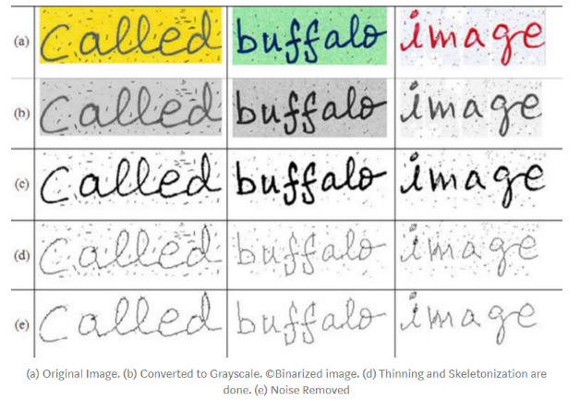

Figure :(a) Original Image (b)Converted to Grayscale (c) Binarized image (d)Thinning and Skeletonization (e) Noise Removal

Thinning and Skeletonization are morphological operations, which process images based on shapes. “Morphological operations apply a structuring element to an input image, creating an output image of the same size. In a morphological operation, the value of each pixel in the output image is based on a comparison of the corresponding pixel in the input image with its neighbors.” [13]

Thinning and Skeletonization is implemented the same way tophat **5.4.3.1** is implemented. We varied the structuring element shape and size to obtain optimal structing element for erosion and opening.

#### Result of Thinning and Skeletonization

Table : Erode Structuring element Optimization sample01.png

|  |  |  |  |  |  |
| --- | --- | --- | --- | --- | --- |
| **Shape Size** | **Structuring element** | **Diamond (1)** | **Disk (2)** | **Square (3)** |  |
| **3** | 509 | 516 | 374 |
| **4** | 509 | 514 | 516 |
| **5** | 511 | 513 | 516 |
| **6** | 508 | 511 | 512 |

Table 10: Erode Structuring element Optimization sample02.png

|  |  |  |  |  |  |
| --- | --- | --- | --- | --- | --- |
| **Shape Size** | **Structuring element** | **Diamond (1)** | **Disk (2)** | **Square (3)** |  |
| **3** | 627 | 581 | 295 |
| **4** | 620 | 623 | 507 |
| **5** | 622 | 620 | 581 |
| **6** | 624 | 624 | 627 |

Table 9 and Table 10 shows the structural element optimization process. The structural element that produces the lowest **Levenshtein Distance** (Most accurate).

However, **most of the time skeletonization is not implemented because it did not result in an improvement in OCR prediction**. As you can see in Table 9 and Table 10 the lowest **Levenshtein Distance** is 374 and 295 respectively, which are very much higher than 167 and 172 in Table 6, Table 7.This means that Skeletonization or erosion actually made the prediction worst. This might be because there seems to be very few irregularities with the characters and thus erosion might only make the characters harder to recognize.

# Improving prediction results of Sample02.png for using Segmentation mask

|  |  |  |
| --- | --- | --- |
| Homomorphic Filtering | Adaptive Thresholding | Tophat Transform |
|  |  |  |

When we compare the results of the different techniques, we can see that Adaptive filtering has the highest OCR prediction accuracy with a **Levenshtein Distance** of 116 while Homomorphic filtering and Tophat has a **Levenshtein Distance** of 631 and 172 respectively.

But when comparing the output images visually we can see that for both Homomorphic filtering and Top hat transform, they both retain more of the original character’s edges and features.

Therefore, this section explores the possibility of using output from optimal thresholding to mask away the background of either Homomorphic filtering or Tophat Transform in order to get a better result than the Optimal Adaptive filtering (**Levenshtein Distance=** 116)

## Methodology and algorithm

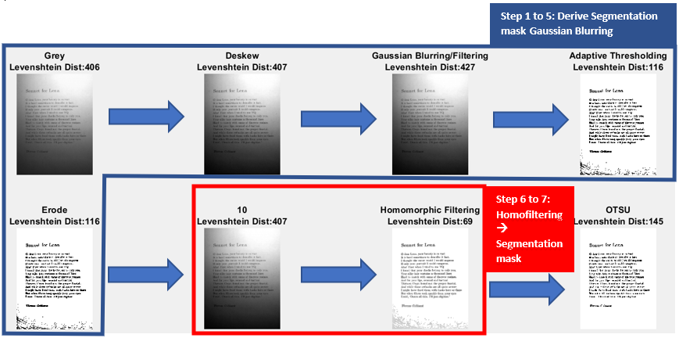

Figure : Optimal workflow for Sample 2 preprocessing

Steps 1 to 5 is deriving the segmentation mask. We carry out the same operations in **5.4.2.1**. Then usingdilation, we the inverted image. In step 6 we create the segmentation mask.

|  |  |
| --- | --- |
| A=find(preprocessing_steps==5);  pic=img_raw_results_cell{A+1};  pic_invert=(pic==0);  se = strel('disk',3);  dilatedI = imdilate(pic_invert,se);  figure;imshowpair(pic_invert,dilatedI,'montage')    prev_img=img_raw_results_cell{i}  mask_array=find(dilatedI==0);    prev_img(find(dilatedI==0)) = 255; | Dilate the inverted **adaptive threshold image**, with a disk structuring element of size 3.  Identify the indexes of pixels that are dark(mask_array). This indexes will help us locate the back ground and we can manipulate the background  For instance  Image(mask_array) = 255;  Will make the back ground bright. |

In step 7 Homomorphic filtering is carried out on the original image but this time at the final step, we mask the results of homomorphic image with the segmentation mask we have created.

|  |  |
| --- | --- |
|  |  |
| **Step1 to 5**  **Derive Segmentation mask Gaussian Blurring 🡪Adaptive Thresholding 🡪Erosion** | **Step 6:**  **Derive Segmentation mask using diation with disk structural element of size 3.** |
| Mask: White Section Transparent |  |
| **Step 7: Conduct homomorphic filtering on original image** | **Step 7: Mask the Results of homorphic filtering with segmentation mask** |

## Result of Homomorphic filtering plus segmentation mask***(BEST) Result for sample02***

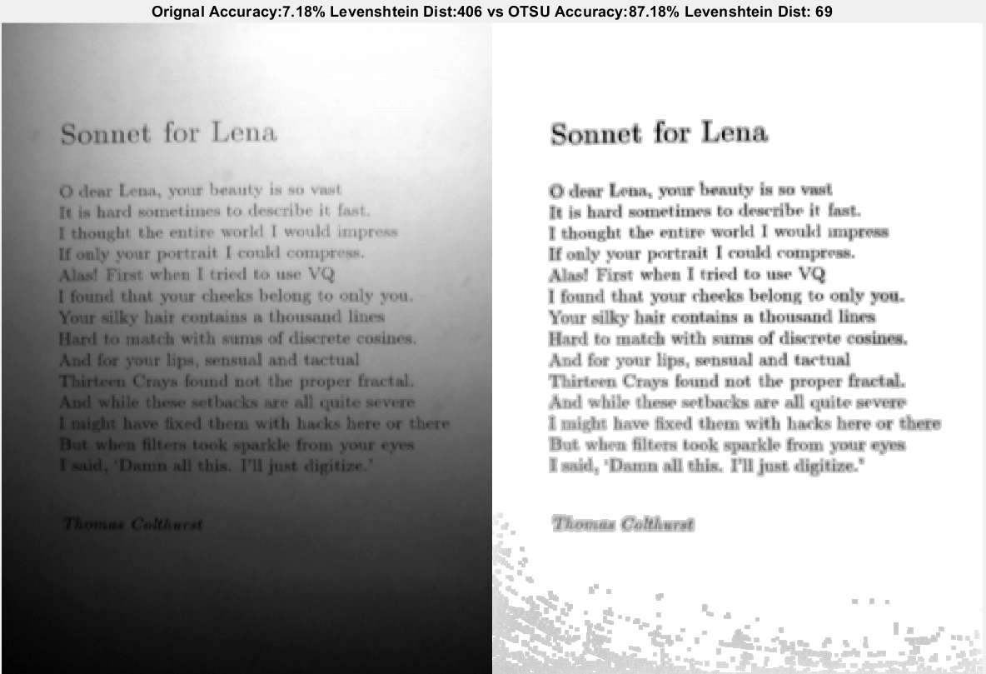

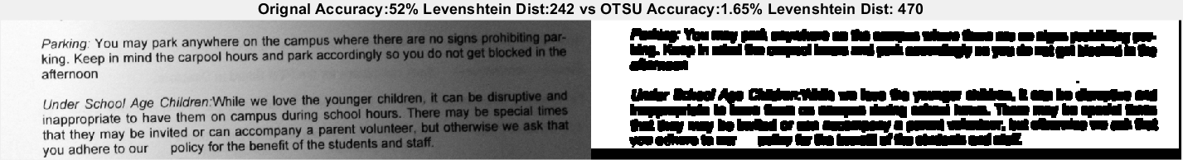

Table : Accuracy Results for Homomorphic Filter🡪Foreground Background Segmentation (Gaussian Blurring 🡪 Adaptive Thresholding 🡪Erosion)

|  |  |  |
| --- | --- | --- |
|  | Sample01.png | Sample02.png ***(BEST) Result for sample02*** |
|  | Gaussian Blurring 🡪Adaptive Thresholding 🡪Erosion | Gaussian Blurring 🡪Adaptive Thresholding 🡪Erosion |
| Accuracy (%) (Manual Change) | 1.65%(-50.47) | 87.18(80) |
| Levensthein Distance [6] | 470(+229) | 69(-337) |

The results of sample 2 is the **best results for sample 2 in the entire paper**. It achieved a 87% accuracy with a very low Levensthein Distance=69. Which is an improvement from the next best of Levensthein Distance=116 derived from Adaptive Thresholding.

By using this technique, contrast stretching, and OTSU thresholding can be applied more effectively because there is lesser interference from the background. However, there is an issue of the partially segmented background skewing the histogram of the image.

As a result, Novel Methods of Contrast stretching, and OTSU was introduced.

## Modified OTSU

For OTSU thresholding, the new methods involve checking if any of the bins contain more than 70% of the count. If there is, that bin’s count will be set to zero so that it does not skew the Optimal OTSU thresholding derived.

|  |
| --- |
| count(find(count>0.7*sum(count(1:256))))=0; |

|  |  |
| --- | --- |
| Original OTSU, Thresholding Skewed by partial segmentation white back ground | |
|  |  |
| Modified OTSU, Thresholding is much better with less skewing from bin=255. | |
|  |  |

## Modified Contrast Stretching

To remove the effects of the white regions due to partial segmentation of the background we first element them. By doing so out p max will not be 255. And this will allow contrast stretching of the other pixels to happen.

|  |  |
| --- | --- |
| function stretched =Contrast_stretch_B_special(gray)  P=gray  P(find(gray==255))=0;  figure('Name',"10 Problem 1");imshow(P)  min_P=double(min(P(:)))%Min intensity=13  max_P=double(max(P(:)))%Max intensity=204  P=uint8((double(P(:,:))-min_P).*(255/(max_P-min_P)));  P(find(gray==255))=255;  figure('Name',"10 Problem 2");imshow(P)  stretched =P;  end | Modified contrast stretching algorithm first changes all 255 to 0 using **index from the original image**  Then Contrast stretching is conducted  Finally using the same **index from the original image** weconvert the pixels which previously has grey levels of 255 back to 255 |

|  |  |
| --- | --- |
| **Original Contrast Stretching (not done properly due to influences from white background)** | **Modified Contrast Stretching (done without influence from white back ground)** |
|  |  |

# OCR Evaluation Matrix

## Primary: Levensthein Distance

**Method**

The primary method of measuring accuracy or similarity of OCR prediction is done using Levenshtein Distance. **When reading the report please depend on Levenshtein Distance. The smaller the Levenshtein Distance the better the accuracy of the OCR results.**

“The Levenshtein Distance is a string metric for measuring the difference between two sequences. Informally, the Levenshtein distance between two words is the minimum number of single-character edits (insertions, deletions or substitutions) required to change one word into the other.” [6]

**Shortcomings** [14]

Levensthein distiance is not robust in handling punctuations, accent marks and capital letters.

Another shortcoming is that it does not account for semantics of a word, For example,

* ‘receive’ misspelled as ‘recieve’ distance of 2 (for 2 substitutions)
* ‘receipt’ is also both 2 substitutional edits

## Secondary: self-written evaluation method

**Methods**

The Secondary evaluation method is a code written by me. The code first breaks down both the ground truth and OCR prediction into a list of sentences. The sentences are then further broken down into a list of words.

For each sentence, each word is compared. If the character matches, 1 is added to the results.

**Assumptions and Short comings**

An assumption made in this code is that the OCR algorithm will at least detect the correct number of words per sentence, which is likely not true. Due to this assumption, the self-written evaluation method is not robust to situations like missing sentence or missing words.

**Mitigation of Short comings**

This miss alignment issues cause a miss calculation of 50% as seen in some situation throughout the papers. Too mitigate this we will manually check and adjust miss aligned output to produce a more accurate OCR accuracy measurement. If manual changes is not possible, we will reject the measurement and depend on the primary evaluation matrix.

## Other: Evaluation to consider Jiwer.

**Note since this matrix is derived from Levensthein Distance, we did not employ this for Evaluation but instead directly used Levensthein Distance as the primary evaluation method.**

This repository was used to approximate the Word Error Rate (WER) of a the OCR output. Using the [Wagner-Fisher](https://en.wikipedia.org/wiki/Wagner%E2%80%93Fischer_algorithm) [15] algorithm, the minimum distance edit distance between the ground-truth sentence and the hypothesis sentence of a Tesseract is computed.

### Word Error Rate(WER) [16]

equation M1

where I = the total number of entries, D = total number of deletions, S = total number of replacements, H = total number of successes, and N1 = total number of reference words

substitution, S- If a word in the reference sequence is transcribed as a different word

deletion, D- When a word is completely missing in the automatic transcription

insertion, I- The appearance of a word in the transcription that has no correspondent in the reference word sequence

“The performance accuracy of a system is usually rated by the word error rate (WER) ([1](https://www.ncbi.nlm.nih.gov/pmc/articles/PMC7256403/#Equ1)), a popular ASR(Automated speech Recognition) comparison index. **It expresses the distance between the word sequence that produces an ASR and the reference series**.

Despite being the most used, WER has some cons. It is not an actual percentage because it has no upper bound. When S = D = 0 and we have two insertions for each input word, then I = N1 (namely when the length of the results is higher than the number of words in the prompt), which means WER = 200%. Therefore it does not tell how good a system is, but only that one is better than another. Moreover, in noisy conditions, WER could exceed 100%, as it gives far more weight to insertions than to deletions.” [16]

Smaller number is better. It measures average error (or the word error rate). Larger Values indicate that a larger probability of the word predicted (excluding insertion) being wrong.

### Match Error Rate (MER) [16]

Match Error Rate (MER) is the proportion of I/O word matches, which are errors, which means **that is the probability of a given match being incorrect.** The ranking behavior of MER ([2](https://www.ncbi.nlm.nih.gov/pmc/articles/PMC7256403/#Equ2)) is between that of WER and WIL

equation M2

Smaller number is better. It measures average error (or the word error rate). Larger Values indicate that a larger probability of the word predicted (including insertion) being wrong.

### Word information lost (WIL) [16]

WIL is a simple approximationto the **proportion of word information lost**

# Conclusions

In conclusion, in this paper we explore the various preprocessing techniques. In particular we have explored **1) Homomorphic Filtering 2) Adaptive Filtering 3) TopHat** Transform to tackle the problem of uneven lighting. We have optimized the preprocessing tools for each individual sample. Given a larger sample, a more general preprocessing flow could be derived. As it stands adaptive filtering seems to be the most general and generally produces the best average OCR accuracy.

In this paper we also introduced unique workflow Homomorphic Filtering with **Segmentation Mask derived from Adaptive Filtering** and introduced **modifications to make Contrast Stretching and OTSU thresholding** more robust to data biases.

# Appendix

## OCR Results for each step

|  |  |
| --- | --- |
| **4.2** Original Sample01.png LD=241 | **4.2** Original Sample02.png LD=406 |
| Parking: You may park anywhere on the ce i  king. Keep in mind the carpool hours and park at  afternoon a  as  Under School Age Children.While we love the }  inappropriate to have them on campus d io  that they may be invited or can accompany a  you adhere to our _policy for the benefit of t he | Sonnet for Lena  1 dear Lena, your !«  is hard sometimes t  Rhonght the entire world |  iy your portrait [ could compr  Firat when I tried to use VQ  your cheeks belong to only you  @ thousand lines  vith sums of discrete cosines.  and tactual i |
| **4.2** OTSU Thresholding Sample01.png LD=249(+8) | **4.2** OTSU Thresholding Sample02.png LD=487(+81) |
| Parking: You may park anywhere on the cans  king. Keep in mind the carpool hours and part  afternoon thd  Under Schoo! Age Children:While we love #iifl  inappropriate to have them on campus d mee  that they may be invited or can accompany 4g  you adhere to our —_policy for the benefit of | Sonnet for ler  Odear Fotucvees |  fw bared stein  bt Che ct ei  your portian Pecula sans  whem Dirial tus Veg  your cheeks belong becins sen  tbutisaud lines  uma of discrete cosines.  and toctual ; |

|  |  |
| --- | --- |
| **Deskew** | |
| **5.2** Deskew -1 Sample01.png LD=236(-5) | **5.2** Deskew 0 Sample02.png LD=407(0) |
| Parking: You may park anywhere on the campus  king. Keep in mind the carpool hours and park at  afternoon oe  Under School Age Children:While we love the y  inappropriate to have them on campus dt  that they may be invited or can accompany a pi  you adhere to our _ policy for the benefit of the | Sonnet for Lena  10 dear Lena, your !«  is hard sometimes t  Bhonght the entire world |  iy your portrait [ could compr  Firat when I tried to use VQ  your cheeks belong to only you  @ thousand lines  vith sums of discrete cosines.  and tactual i |



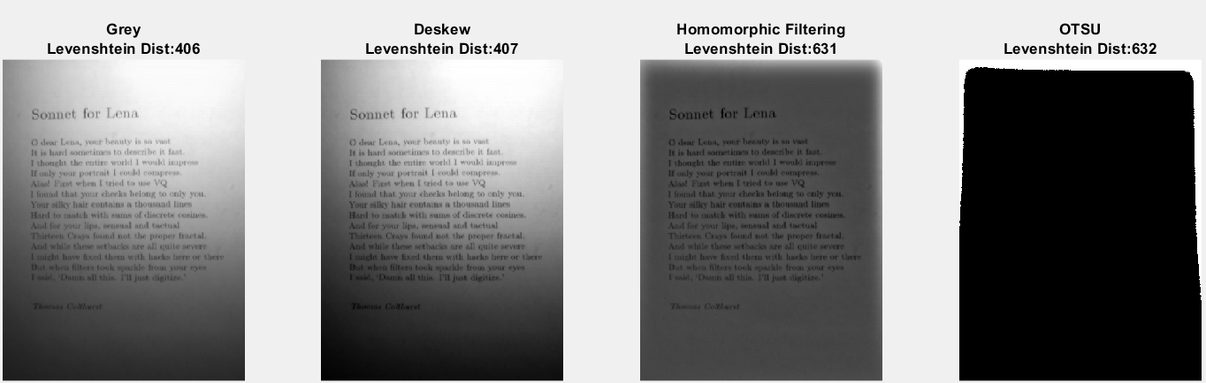

|  |  |
| --- | --- |
| **Homomorphic filtering [4] [6] 🡪Contrast 🡪OTSU** | |
| **5.4.1.2**Homomorphic filtering🡪Contrast Sample01.png LD=6(-235) ***(BEST) Result for sample01*** | **5.4.1.2**Homomorphic filtering🡪Contrast Sample02.png LD=631(+225) |
| Parking: You may park anywhere on the campus where there are no signs prohibiting par-  king. Keep in mind the carpool hours and park accordingly so you do not get blocked in the  afternoon  Under School Age Children.While we love the younger children, it can be disruptive and  inappropriate to have them on campus during school hours. There may be special times  that they may be invited or can accompany a parent volunteer, but otherwise we ask that  you adhere to our __ policy for the benefit of the students and staff. |  |
| **5.4.1.2**Homomorphic filtering🡪Contrast🡪OTSU Sample01.png LD=6(-235) | **5.4.1.2**Homomorphic filtering🡪Contrast🡪OTSU Sample02.png LD=632(+226) |
| Parking. You may park anywhere on the campus where there are no signs prohibiting par-  king. Keep in mind the carpool hours and park accordingly so you do not get blocked in the  afternoon  Under Schoo! Age Children:While we love the younger children, it can be disruptive and  inappropriate to have them on campus during school hours. There may be special times  that they may be invited or can accompany a parent volunteer, but otherwise we ask that  you adhere to our _ policy for the benefit of the students and staff. |  |



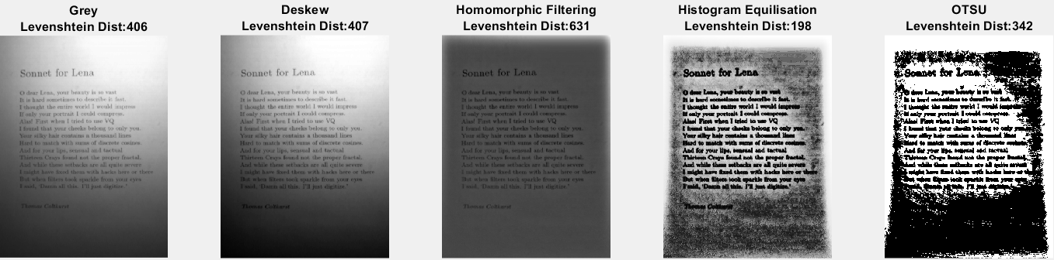

|  |  |
| --- | --- |
| **Homomorphic filtering [4] [6] 🡪 Hist Eqi🡪OTSU** | |
| **5.4.1.2**Homomorphic filtering🡪Contrast🡪Hist Equi Sample01.png LD=22(-219) | **5.4.1.2**Homomorphic filtering🡪Contrast🡪Hist Equi Sample02.png LD=198(-208) |
| Parking: You may park anywhere on the campus Where there are no signs prohibiting par-  king, Keep in mind the carpool hours and park accordingly so you do not get blocked in th 3  afternoon %  ‘Under School Age Children:While we love the younger children, it can be disruptive and  inappropriate to have them on campus during school hours. Th mn May be special times  that they may be invited or can accompany a parent volunteer, but otherwise we ask that  ‘you adhere to our” policy for the benefit of the students and staff. ~ e | ie s og oe al  Ag dear Lena, yout beauty la ea vest "oo ‘gy  "iu in hard sometimes to describe It feat.  # [thought the entire world 1 would impress 72>  © Ml enly your portrait I could compress. §< == 57  ‘ Figet when I tried to use VQ a,  ©, 1 found that your cheeks belong to only your" >  +. Your ailky hait contains » thousand lines >  hy Hard to match with sums of discrete cosinen: <  {And for your lips, sensual and tactual ae  A ae Crays found not the proper fractal.  yo) And while these setbacks are all quite severe G  ll might have fixed them with hacks here or there  '}:: But when filters took sparkle from your eyee 350)  ig | Weald, ‘Deasm olf thin. TH fost digitize." a  oo ina Secale .  f \ Y r e  Y f foe q  errata eae re ee ee Fy |
| **5.4.1.2**Homomorphic filtering🡪Contrast🡪Hist Equi 🡪OTSU Sample01.png LD=106(-135) | **5.4.1.2**Homomorphic filtering🡪Contrast🡪Hist Equi 🡪OTSU Sample02.png LD=342(-64) |
| Parking: You may park anywhere on the campus where tere &1g DO Sais RrOnDenn Ble  king. Keep in mind the carpoo! hours and park accordingly vol do ol a oad Be -  afternoon. 4  “Under joo! Age Children:While we love tie younger chidneh, & ean. a. Garup an  inappropriate to have them on campus during ‘school hours. T hen b pec i ton  that they may be invited or can accompany a parent volunteér, bit otharwite vib bak Hat  you adhere to our —_ policy for the benefit of the students and stella | Pee kee  3 eS oe gg  i Sonnet for Lena <a  a ae ae  oe: yg ocasch pee  deer Loon, yout tunuty le os vat SRE  AN be in herd socmetionas to describe it fail J 23 oa  AR it caly your portrait | ceeld compress. aa  as First whea Itrled boue VQ 7-H,  Sry 3 found thet ywor chinks belong to only puting  Si Yous aiky bade contains » thowssed Maes aii  Pee tlard to match with vorns of diacrets sosinen 2  %. And fer your lps, semeua) apd tactaal =  = Cenps Sound not the proper Iressa. SE |  SRE naight have fined thems with lacks hare at thie”  Etbet when Glue took sparkle kom your yan. 28  Oa a sae ae  We a — .  .. |

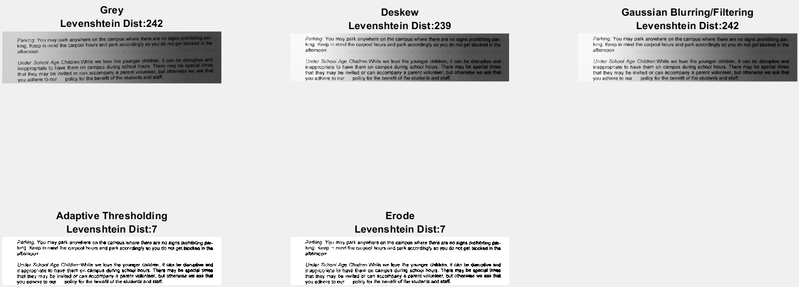

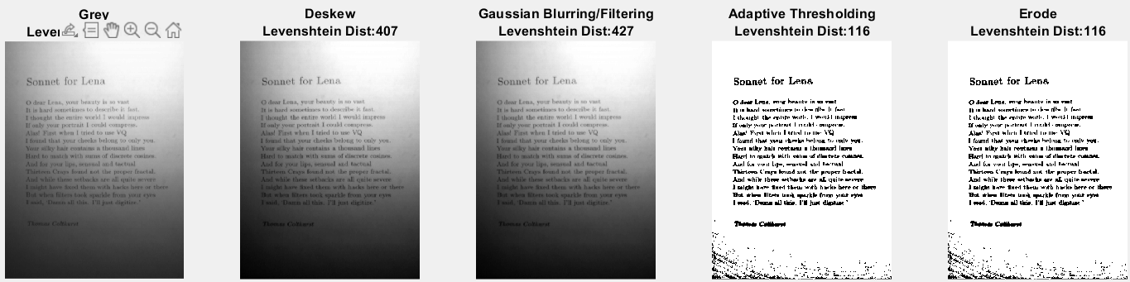

|  |  |
| --- | --- |
| **Gaussian Blurring 🡪 Adaptive Thresholding 🡪Erosion** | |
| **5.4.2.2 Gaussian Blurring 🡪 Adaptive Thresholding 🡪Erosion** Sample01.png LD=7(-234) ***(BEST average) Result for Both*** | **5.4.2.2 Gaussian Blurring 🡪Adaptive Thresholding 🡪Erosion** Sample02.png LD=116(-290) ***(BEST average) Result for Both*** |
| Parking. You may park anywhere on the campus where there are no signs prohibiting par-  king. Keep in mind the carpool hours and park accordingly so you do not get blocked in the  afterncon  Under School Age Children:While we love the younger children, it can be disruptive and  inappropriate to have them on campus during school hours. There may be special times  that they may be invited or can accompany a parent volunteer, but otherwise we ask that  you adhere to our _—poficy for the benefit of the students and staff. | Sonnet for Lena  O dear Lona, cour fenuty in po wast  It ia bard soinetimes ta dlesctihe it fast  Lthongbt the entire work! P would anipreae  {fonty sour portrait Lcnokd compress.  Alas’ Firat when] trim) te nee VQ  I found that yuor cheeks belong to only you.  Your silky hair contains a thonsand lines  Hard to match with mums of disrrete cosines.  And for your lips, nenaval and tertual  Thirtern Crays found wut ibe proper fractal.  And while three setbacks are all quite severe  1 might bave fixed them with hacka bere or there  Bot when filters took sparkle from your eyrw  Tesid, ‘Damm all thie. I'll just digitize.”  ee naa he ae a Pye, eae ee A |

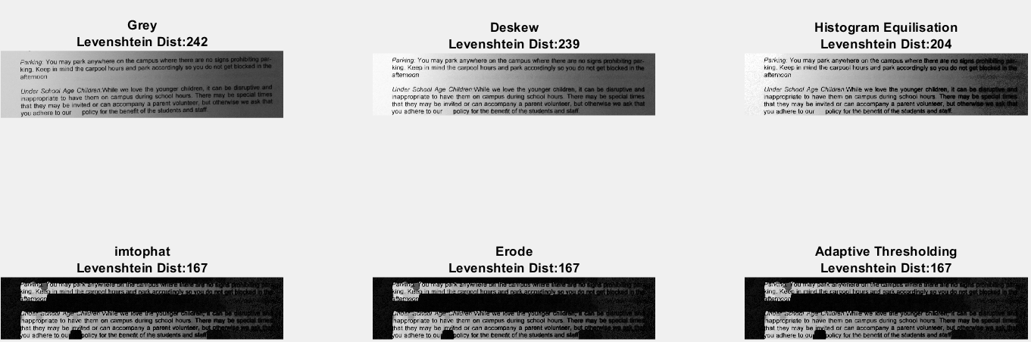  
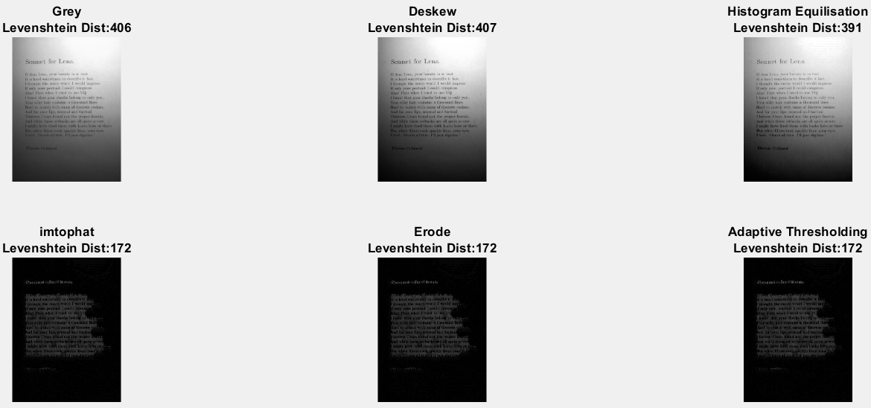

|  |  |
| --- | --- |
| **Tophat Transform🡪Erode 🡪 Adaptive Thresholding** | |
| **5.4.3.2 Histogram Equilisation →Tophat→Erode→Optimized Adaptive Thresholding** Sample01.png LD=167(-74) | **5.4.3.2 Histogram Equilisation →Tophat→Erode→Optimized Adaptive Thresholding** Sample02.png LD=172(-234) |
| Y park anywhere on the campus where tel No sigt  fs nd the carpool ho and park accordingly so you do not |  Unters Age Children. While we love ine younger children, 1 cal  inappropriate to have them on campus during school hours. There” nay t  hat they may be jpyited or can accompany a parent volunteer, buto v  fou adhere to ou olicy for the benefit of the students and staff | Sopa etd ee Ronee ents  7 ent bs v tt A  tis hard sometinies to describe it i  thonght the entire world [ would impgg  fonly your portrait [ could comprgga  Jas First when T tried to use VQ  found tint your cheeks belong to OOTY og  ‘our silky liait contains © thousand lines  fard to miatch with sums of discrete oosiits  nd for your lips, sensual and tactui  Thirteen Crays fotind not the proper al  nd while these. eetbacks-aire all quite severe  might have fixtd them with lacks lrere or ZR  jut when filters took «parkle frow your tym  CLE het tl Tas |

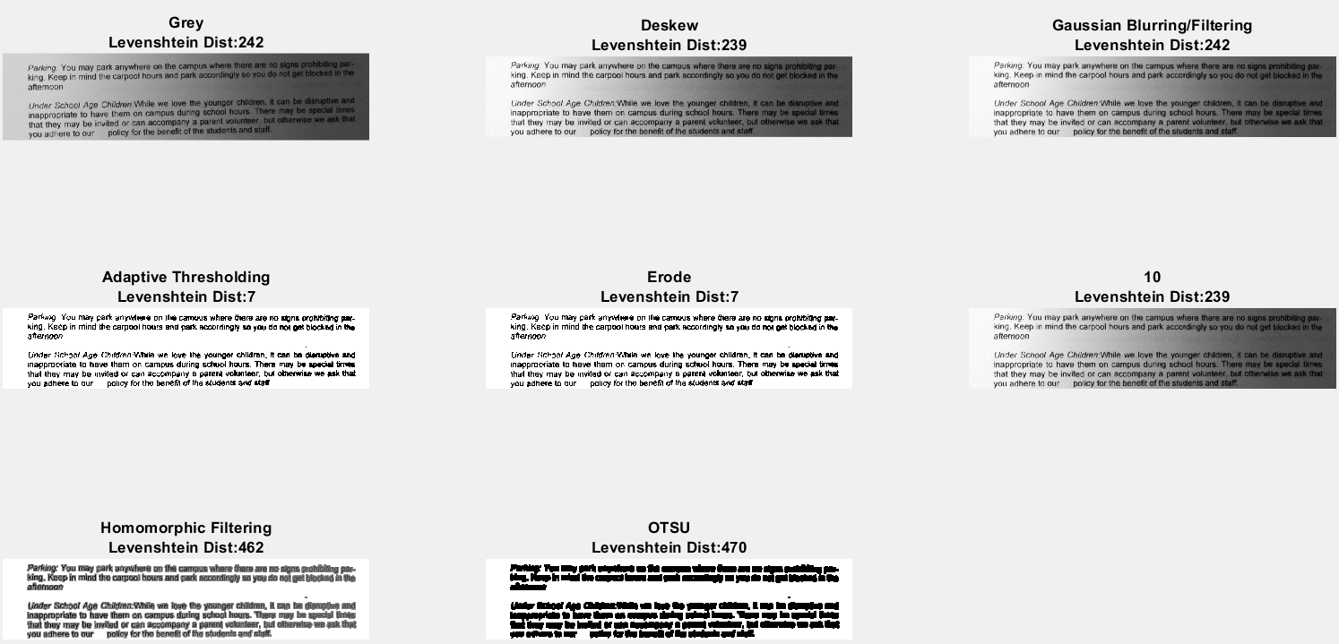

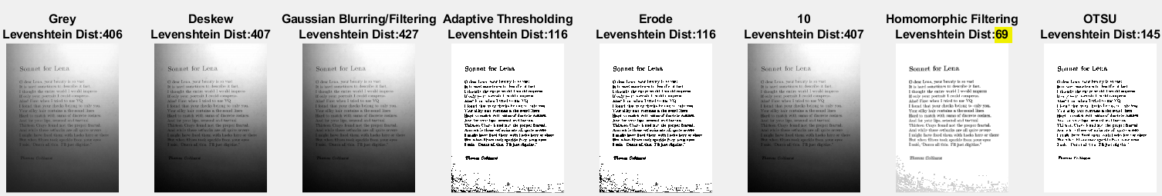

|  |  |
| --- | --- |
| **Homomorphic Filter🡪Foreground Background Segmentation (Gaussian Blurring 🡪 Adaptive Thresholding 🡪Erosion)** | |
| **6.2**Homomorphic filtering🡪 Foreground Background Segmentation Sample01.png LD=470(+229) | **6.2**Homomorphic filtering🡪 Foreground Background Segmentation Sample02.png LD=69(-337)  ***(BEST) Result for sample02*** |
| Gis apn as spor oon pat yor soso  Sentesener ae eas | Sonnet for Lena  © dear Lena, your beauty is so vast  It is hard sometimes to deseribe it fast.  T thought the entire world | would impress  Tf only your portrait [ could compress.  Alas! First when I tried to use VQ  I found that your cheeks belong to only you.  Your silky hair contains a thousand lines  Hard to match with sums of discrete cosines.  And for your lips, sensual and tactual  Thirteen Crays found not the proper fractal.  And while these setbacks are all quite severe  ‘I might have fixed them with hacks here or there  But when filters took sparkle from your eyes  Issid, Dann all this, I'll just digitize.”  Thomas Cotthurst  SP  e weg  see a a  oy A oe - So Ia P aes |

# Code

## OTSU_B.m

function threshold =OTSU_B(gray, Analysis)

%OTSU Thresholding

[count,bins]=imhist(uint8(gray),256);

count(find(count>0.7*sum(count(1:256))))=0;

%Maximise intraclass variance

size(count)

inter_class_var=zeros(size(bins,1),1);

for n=1:size(bins,1)

%Mean of L(backgnd)and H(foregnd)

mean_L=dot(count(1:n),bins(1:n))/sum(count(1:n));

mean_H=dot(count(n+1:256),bins(n+1:256))/sum(count(n+1:256));

weight_L=sum(count(1:n))/sum(count);

weight_H=sum(count(n+1:256))/sum(count);

inter_class_var(n)=weight_L*weight_H*(mean_L-mean_H)^2;

end

[M,I] = max(inter_class_var)

%Analysis Report

if Analysis ==true

%Plot Interclass variance

figure( 'Position', [10 10 900 600]);

subplot(1,2,1);plot(bins,inter_class_var);

hold on;

plot(bins(I),inter_class_var(I),'o',...

'MarkerEdgeColor','red',...

'MarkerFaceColor',[1 .6 .6])

title({'Inter class variance','{\sigma}^2-{\sigma _w}^2={W}_L{W}_H({\mu _L}+{\mu _H})^2'})

xlabel('Threshold, t');

ylabel('Inter class variance, {\sigma}^2-{\sigma _w}^2');

%Plot histogram with OTSU threshold

subplot(1,2,2);imhist(uint8(gray),256);title("Histogram with OTSU Threshold");

hold on;

xline(bins(I),'-r',{'OTSU Threshold',strcat('t= ',num2str(bins(I)))})

end

threshold=bins(I)

end

## OCRMain.m (Run this code)

clear all;

close all;

%%%%%%%%%%%%%%%%%%%%%%%%%%%%%%%%%%%%%%%%%%%%%%%%%%%%%%%%%%%%%%%

%Readme%

%Please Select:

%1.Sample_no-> indicate which sample to run the preproceesing on

%2.preprocessing_steps-> Uncomment the preprocessing steps to be execused

%their corresponding report section is indicated.

%%%%%%%%% 1.Select Sample%%%%%%%%%%%%%%%%%%%%%%%%%%%%%%%%%%%%%%%%%%

sample_no=2

%%%%%%%%% 2.Uncomment Processing Steps to be executed%%%%%%%%%%%%%%

%"0 Grey", "1 OTSU", "2 Deskew" "3 Homomorphic Filtering", "4 Histogram Equilisation",...

% "5 Adaptive Thresholding", "6 Opening","7 erode",...

% "8 Gaussian Blurring/Filtering","9 imtophat"

%4

%OTSU

%preprocessing_steps=[1]

%5.4.1

%Deskew-> Homo-> OTSU

%%%%%%%%%%%%%%%%%%%%%%%BEST for sample 1%%%%%%%%%%%%%%%%%%%%%%%%%%%%%%%%%%%

%preprocessing_steps=[2 3 1]

%Deskew-> Homo->Hist Equi ->OTSU

%preprocessing_steps=[2 3 4 1]

%5.4.2

%Deskew-> Gaussian ->Adapt_T-> erode

%%%%%%%%%%%%%%%%%%BEST for in General Sample 1 and Sample 2%%%%%%%%%%%%%%%

%preprocessing_steps=[2 8 5 7]

%5.4.3

%Deskew->Hist Equi-> Tophat-> erode-> Adapt_T

%preprocessing_steps=[2 4 9 7 5]

%6

%Deskew-> Gaussian ->Adapt_T-> erode->10->Homo+ Segment-> OTSU

%%%%%%%%%%%%%%%%%%%%%BEST for sample 2%%%%%%%%%%%%%%%%%%%%%%%%%%%%%%%%%%%%

preprocessing_steps=[2 8 5 7 10 3 1]

%Others

%Deskew-> Gaussian ->Adapt_T-> erode->10->Tophat+ Segment-> erode-> Adapt_T

%preprocessing_steps=[2 8 5 7 10 9 7 5]

%Deskew->Hist Equi-> Tophat->Gaussian ->Adapt_T-> erode

%preprocessing_steps=[2 4 9 8 5 7]

%Deskew-> Homo->Hist Equi-> Gaussian ->Adapt_T-> erode

%preprocessing_steps=[2 3 8 5 7]

%add the current folder to the Python search path.

%Run Matlab 2020

if count(py.sys.path,'') == 0

insert(py.sys.path,int32(0),'');

end

tool_Name={"Grey", "OTSU", "Deskew" "Homomorphic Filtering", "Histogram Equilisation",...

"Adaptive Thresholding", "Opening","Erode",...

"Gaussian Blurring/Filtering","imtophat","10"}

img_file=["resource/sample01.png " "resource/sample02.png "]

N=size(preprocessing_steps,2)

img_raw_results_cell=cell(N+1,1);

Results_overall=zeros(2,N+1)

Pc = imread(img_file(sample_no));

whos Pc

if(size(Pc,3)==3)

P_gray = rgb2gray(Pc);

else

P_gray = Pc;

end

img_raw_results_cell{1}=P_gray

mask_array=-1

for i=1:N

%1 OTSU

if preprocessing_steps(i)==1

%2 OTSUP=double(py.Overall_OCR.deskew(P));

P=Contrast_stretch_B(img_raw_results_cell{i}); %2.1 Contrast stretching

t=OTSU_B(P,true); %2.2 OTSU Global Thesholding

P=P>t;

img_raw_results_cell{i+1}=P;

%Step 2: Deskew

%2 Deskew

elseif preprocessing_steps(i)==2

img_raw_results_cell{i+1}=Contrast_stretch_B(double(py.numpy.array(py.Overall_OCR.deskew(img_raw_results_cell{i}))));

%Step 4: Binarisation

%3 Homomorphic Filtering

elseif preprocessing_steps(i)==3

%3 Homomorphic Filtering + Contrast Stretching +OTSU

P=HOMO_Filtering_B(img_raw_results_cell{i}); %3.1 Homomorphic Filtering

img_raw_results_cell{i+1} = Contrast_stretch_B(P); %3.2 Contrast stretching

if mask_array~=-1

img_raw_results_cell{i+1}(mask_array) = 255;

img_raw_results_cell{i+1} = Contrast_stretch_B(img_raw_results_cell{i+1});

end

%4 Histogram Equilisation

elseif preprocessing_steps(i)==4

P=Contrast_stretch_B(img_raw_results_cell{i});

img_raw_results_cell{i+1} = histeq(P ,255); %histogram equilisation

%5 Adaptive Thresholding

elseif preprocessing_steps(i)==5

%S_varry=linspace(0.659,0.67,50)

S_varry=linspace(0.3,0.9,50);

%S_varry=linspace(0,1,100)

result_to=zeros(1,size(S_varry,2));

for k=1:size(S_varry,2)

BW=BW_adaptT(img_raw_results_cell{i}, S_varry(k));

result_pre=cellfun(@double,cell(py.Overall_OCR.tesseractOCR(BW,sample_no)));

result_to(k)=result_pre(2);

end

[M,I] = min(result_to);

M

S_varry(I)%0.661

figure;plot(S_varry, result_to);

hold on;

plot(S_varry(I),M,'o',...

'MarkerEdgeColor','red',...

'MarkerFaceColor',[1 .6 .6])

;xlabel('Sensitivity [0.659,0.67]');ylabel('Accuracy');

legend(['Levenshtein Dist: ']...

,[strcat('Best Levenshtein Dist: @(S=',num2str(round(S_varry(I),4)),')=',num2str(round(M,2)))] ...

,'Location','best');

result_O=cellfun(@double,cell(py.Overall_OCR.tesseractOCR(img_raw_results_cell{i},sample_no)));

if result_O(2)<M

img_raw_results_cell{i+1}=img_raw_results_cell{i}

else

img_raw_results_cell{i+1}=BW_adaptT(img_raw_results_cell{i}, S_varry(I));

end

%Step 5: Skeletionisation

%6 Opening, erode,7,erode,9,imtophat

elseif ismember(preprocessing_steps(i),[6,7,9])

shape_element={'diamond','disk','square';}

shape_element_no=linspace(1,size(shape_element,2),size(shape_element,2));

if preprocessing_steps(i)==6

r=[3,4,5,6]

elseif preprocessing_steps(i)==7

r=[3,4,5,6]

elseif preprocessing_steps(i)==9

r=[9,10,11,12]

end

pic=imcomplement(img_raw_results_cell{i});

result_to= zeros(size(r,2),size(shape_element,2))

[X,Y] = meshgrid(shape_element_no,r)

for j = 1:size(shape_element,2)

for p = 1:size(r,2)

se = strel(shape_element{j},r(p));

if preprocessing_steps(i)==6

img = imcomplement(imopen(pic,se));

elseif preprocessing_steps(i)==7

img = imcomplement(imerode(pic,se));

elseif preprocessing_steps(i)==9

img = imtophat(imcomplement(pic),se);

end

result_pre=cellfun(@double,cell(py.Overall_OCR.tesseractOCR(img,sample_no)));

result_to(p,j)=result_pre(2);

end

end

minMatrix = min(result_to(:));

[row,col] = find(result_to==minMatrix);

figure( 'Position', [10 10 900 600]);

subplot(3,2,1);mesh(X,Y,result_to,'FaceAlpha','0.8'),title('imopen()'),xlabel('shape_element'),ylabel('r'),zlabel('result');

result_to

se = strel(shape_element{col},r(row));

result_O=cellfun(@double,cell(py.Overall_OCR.tesseractOCR(img_raw_results_cell{i},sample_no)));

if result_O(2)<minMatrix

img_raw_results_cell{i+1}=img_raw_results_cell{i}

else

if preprocessing_steps(i)==6

img_raw_results_cell{i+1} = imcomplement(imopen(imcomplement(img_raw_results_cell{i}),se));

elseif preprocessing_steps(i)==7

img_raw_results_cell{i+1} = imcomplement(imerode(imcomplement(img_raw_results_cell{i}),se));

elseif preprocessing_steps(i)==9

img_raw_results_cell{i+1} = imtophat(img_raw_results_cell{i},se);

if mask_array~=-1

img_raw_results_cell{i+1}(mask_array) = 255;

img_raw_results_cell{i+1} = Contrast_stretch_B_special(img_raw_results_cell{i+1});

end

end

end

%8 Gaussian Blurring/Filtering

elseif preprocessing_steps(i)==8

sigma=linspace(0.5,4,10);

result_to=zeros(1,size(sigma,2));

for k=1:size(sigma,2)

img=imgaussfilt(img_raw_results_cell{i},sigma(k));

result_pre=cellfun(@double,cell(py.Overall_OCR.tesseractOCR(img,sample_no)));

result_to(k)=result_pre(2);

end

[Sigma_M,I] = min(result_to);

Sigma_M

sigma(I)%0.661

img_raw_results_cell{i+1}=imgaussfilt(img_raw_results_cell{i},sigma(I))

%10 Mask From Best Soltuion method

elseif preprocessing_steps(i)==10

A=find(preprocessing_steps==5);

pic=img_raw_results_cell{A+1};

pic_invert=(pic==0);

se = strel('disk',3);

dilatedI = imdilate(pic_invert,se);

figure;imshowpair(pic_invert,dilatedI,'montage')

prev_img=img_raw_results_cell{i}

mask_array=find(dilatedI==0);

prev_img(find(dilatedI==0)) = 255;

img_raw_results_cell{i+1}=img_raw_results_cell{2}

end

end

figure( 'Position', [5 5 1400 500]);

for i=1:size(img_raw_results_cell,1)

Results_overall(:,i)=cellfun(@double,cell(py.Overall_OCR.tesseractOCR(img_raw_results_cell{i},sample_no)));

if i==1;

Process_Name=tool_Name{i};

else

Process_Name=tool_Name{preprocessing_steps(i-1)+1};

end

subplot(1,N+1,i);imshow(img_raw_results_cell{i});title([strcat(Process_Name,'\rightarrow') ,strcat('Levenshtein Dist: ', num2str(round(Results_overall(2,i),2)))]);

end

figure;imshowpair(img_raw_results_cell{1},img_raw_results_cell{N+1},'montage'),title([strcat('Orignal Accuracy: ',num2str(round(Results_overall(1,1),2)),'% Levenshtein Dist: ', num2str(round(Results_overall(2,1),2))...

, '. Vs .', tool_Name{preprocessing_steps(N)+1},num2str(round(Results_overall(1,N+1),2)),'% Levenshtein Dist: ', num2str(round(Results_overall(2,N+1),2)))]);

S=4

figure;imshowpair(img_raw_results_cell{1},img_raw_results_cell{S},'montage'),title([strcat('Orignal Accuracy: ',num2str(round(Results_overall(1,1),2)),'% Levenshtein Dist: ', num2str(round(Results_overall(2,1),2))...

,'. Vs .', tool_Name{preprocessing_steps(S-1)+1},num2str(round(Results_overall(1,S),2)),'% Levenshtein Dist: ', num2str(round(Results_overall(2,S),2)))]);

## Contrast_stretch_B.m

function stretched =Contrast_stretch_B(gray)

min_P=double(min(gray(:)))%Min intensity=13

max_P=double(max(gray(:)))%Max intensity=204

stretched = uint8((double(gray(:,:))-min_P).*(255/(max_P-min_P)));

end

## Contrast_stretch_B_special.m

function stretched =Contrast_stretch_B_special(gray)

P=gray

P(find(gray==255))=0;

figure('Name',"10 Problem 1");imshow(P)

min_P=double(min(P(:)))%Min intensity=13

max_P=double(max(P(:)))%Max intensity=204

P=uint8((double(P(:,:))-min_P).*(255/(max_P-min_P)));

P(find(gray==255))=255;

figure('Name',"10 Problem 2");imshow(P)

stretched =P;

end

## HOMO_Filtering_B.m

function Ihmf =HOMO_Filtering_B(gray)

%https://blogs.mathworks.com/steve/2013/06/25/homomorphic-filtering-part-1/

I = gray;

%imshow(I)

I = im2double(I);

I = log(1 + I);

M = 2*size(I,1) + 1;

N = 2*size(I,2) + 1;

%Creating High Pass Filter

sigma = 10;

[X, Y] = meshgrid(1:N,1:M);

centerX = ceil(N/2);

centerY = ceil(M/2);

gaussianNumerator = (X - centerX).^2 + (Y - centerY).^2;

H = exp(-gaussianNumerator./(2*sigma.^2));

H = 1 - H;

figure( 'Position', [10 10 900 600]);

subplot(1,2,1);imshow(H);title('High Pass Filter \sigma =10')

subplot(1,2,2);mesh(X,Y,H,'FaceAlpha','0.8'),title('High Pass Filter \sigma =10'),xlabel('X'),ylabel('Y'),zlabel('Z');

H = fftshift(H);

If = fft2(I, M, N);

%Pass fft2 image through High Pass Filter

Iout = real(ifft2(H.*If));

Iout = Iout(1:size(I,1),1:size(I,2));

Ihmf = exp(Iout) - 1;

end

## BW_adaptT.m

function BW =BW_adaptT(gray, sensitivity)

%https://www.mathworks.com/help/images/ref/adaptthresh.html#namevaluepairs

%Sensitivity: Determine which pixels get thresholded as foreground pixels,

%specified as a number in the range [0, 1].

%High sensitivity values lead to thresholding more pixels as foreground,

%at the risk of including some background pixels.

I=gray;

T = adaptthresh(I, sensitivity);

BW = (imbinarize(I,T));

%BW=double((I>100).*255);

%figure

%imshowpair(I, BW, 'montage')

end

## Overall_OCR.py

1. #for pytesseract
2. #conda install -c conda-forge pytesseract
3. #https://medium.com/analytics-vidhya/performing-optical-character-recognition-with-python-and-pytesseract-using-anaconda-4bfe1ee6a75f
4. #for CV2
5. #conda install -c conda-forge opencv
6. #for Matlab
7. #https://stackoverflow.com/questions/46141631/running-matlab-using-python-gives-no-module-named-matlab-engine-error
8. **import** cv2
9. **import** pytesseract
10. pytesseract.pytesseract.tesseract_cmd=r'C:\Program Files\Tesseract-OCR\tesseract.exe'
11. **import** matplotlib.pyplot as plt
12. **import** numpy as np
13. #import jiwer
14. **import** matlab.engine
15. **import** sys
16. **import** scipy.io
17. **import** Levenshtein
18. **from** scipy.ndimage **import** interpolation as inter
19. **import** math
21. #https://nanonets.com/blog/ocr-with-tesseract/
23. # get grayscale image
24. **def** get_grayscale(image):
25. **return** cv2.cvtColor(image, cv2.COLOR_BGR2GRAY)
27. # noise removal
28. **def** remove_noise(image):
29. **return** cv2.medianBlur(image,5)
31. #thresholding
32. **def** thresholding(image):
33. **return** cv2.threshold(image, 0, 255, cv2.THRESH_BINARY + cv2.THRESH_OTSU)[1]
35. #dilation
36. **def** dilate(image):
37. image=np.asarray(image)
38. kernel = np.ones((5,5),np.uint8)
39. img_dialate=cv2.dilate(image, kernel, iterations = 1)
40. data=np.ascontiguousarray(img_dialate)
41. data=matlab.double(data.tolist())
42. **return** data
44. #erosion
45. **def** erode(image):
46. image=np.asarray(image)
47. kernel = np.ones((5,5),np.uint8)
48. img_erode=cv2.erode(image, kernel, iterations = 1)
49. data=np.ascontiguousarray(img_erode)
50. data=matlab.double(data.tolist())
51. **return** data
53. #opening - erosion followed by dilation
54. **def** opening(image):
55. image=np.asarray(image)
56. kernel = np.ones((5,5),np.uint8)
57. img_open=cv2.morphologyEx(image, cv2.MORPH_OPEN, kernel)
58. data=np.ascontiguousarray(img_open)
59. data=matlab.double(data.tolist())
60. **return** data
62. #canny edge detection
63. **def** canny(image):
64. image=np.asarray(image)
65. **return** cv2.Canny(image, 100, 200)
67. **def** deskew(img):
68. img=np.asarray(img)
69. bin_img=cv2.adaptiveThreshold(img,1,cv2.ADAPTIVE_THRESH_GAUSSIAN_C,cv2.THRESH_BINARY,11,2)
70. delta = 1
71. limit = 5
72. angles = np.arange(-limit, limit+delta, delta)
73. scores = []
74. **for** angle **in** angles:
75. hist, score = find_score(bin_img, angle)
76. scores.append(score)
77. best_score = max(scores)
78. best_angle = angles[scores.index(best_score)]
79. #plot
80. ##    hist1, score1 = find_score(bin_img, 0)
81. ##    hist2, score2 = find_score(bin_img, angle)
82. ##    histo=[hist1,hist2]
83. ##    plt.rcdefaults()
84. ##    figure, ax = plt.subplots(nrows=1,ncols=2 )
85. ##    for ind,title in enumerate(histo):
86. ##        y_pos = np.arange(len(histo[ind]))
87. ##        ax.ravel()[ind].barh(y_pos,histo[ind])
88. ##        ax.ravel()[ind].set_xlabel('no. of black pixels')
89. ##        ax.ravel()[ind].set_ylabel('Image row number')
90. ##    plt.tight_layout()
91. ##    plt.show()
93. **print**('Best angle: {}'.format(best_angle))
94. # correct skew
95. data = inter.rotate(img, best_angle, reshape=False, order=0)
96. hist_white = np.sum(data==0, axis=1)
97. **print**(data)
98. ##    plt.rcdefaults()
99. ##    fig, ax = plt.subplots()
100. ##    y_pos = np.arange(len(hist_white))
101. ##    ax.barh(y_pos,hist_white)
102. ##    ax.set_xlabel('no. of white pixels')
103. ##    ax.set_ylabel('Image row number')
104. ##    plt.show()
105. (h,w)=img.shape
107. mw,mh=rotatedRectWithMaxArea(w, h, abs(math.radians(best_angle)))
108. dw=math.ceil((w-mw)/2)
109. dh=math.ceil((h-mh)/2)
110. data=np.ascontiguousarray((data))
111. **print**(w,h)
112. **print**(mw,mh)
113. **print**(dw,dh)
114. data=matlab.double(data[dh:h-dh,dw:w-dw].tolist())
115. #data=np.asarray(data[dh:h-dh,dw:w-dw])
116. #.tolist()
117. **return** data

120. **def** find_score(arr, angle):
121. data = inter.rotate(arr, angle, reshape=False, order=0)
122. hist = np.sum(data, axis=1)
123. score = np.sum((hist[1:] - hist[:-1]) ** 2)
124. **return** hist, score
126. **def** rotatedRectWithMaxArea(w, h, angle):
127. """
128. https://stackoverflow.com/questions/16702966/rotate-image-and-crop-out-black-borders
129. Given a rectangle of size wxh that has been rotated by 'angle' (in
130. radians), computes the width and height of the largest possible
131. axis-aligned rectangle (maximal area) within the rotated rectangle.
132. """
133. **if** w <= 0 **or** h <= 0:
134. **return** 0,0
136. width_is_longer = w >= h
137. side_long, side_short = (w,h) **if** width_is_longer **else** (h,w)
139. # since the solutions for angle, -angle and 180-angle are all the same,
140. # if suffices to look at the first quadrant and the absolute values of sin,cos:
141. sin_a, cos_a = abs(math.sin(angle)), abs(math.cos(angle))
142. **if** side_short <= 2.*sin_a*cos_a*side_long **or** abs(sin_a-cos_a) < 1e-10:
143. # half constrained case: two crop corners touch the longer side,
144. #   the other two corners are on the mid-line parallel to the longer line
145. x = 0.5*side_short
146. wr,hr = (x/sin_a,x/cos_a) **if** width_is_longer **else** (x/cos_a,x/sin_a)
147. **else**:
148. # fully constrained case: crop touches all 4 sides
149. cos_2a = cos_a*cos_a - sin_a*sin_a
150. wr,hr = (w*cos_a - h*sin_a)/cos_2a, (h*cos_a - w*sin_a)/cos_2a
152. **return** wr,hr
154. #template matching
155. **def** match_template(image, template):
156. **return** cv2.matchTemplate(image, template, cv2.TM_CCOEFF_NORMED)
158. #OCReval Evaluate OCR results
159. **def** OCReval(Actual,prediction):
160. #Step 1:Preprocessing
161. Actual=Actual.split("\n")
162. prediction=prediction.split("\n")
164. **for** idx, val **in** enumerate(prediction):
165. prediction[idx]=val.split(" ")
167. **for** idx, val **in** enumerate(Actual):
168. Actual[idx]=val.split(" ")

171. #Step 2:Evaluating Accuracy
172. results=Actual.copy();
173. **for** i, line **in** enumerate(Actual):
174. **for** j, word **in** enumerate(line):
175. **try**:
176. Actual_word=list(word)
177. OCR_word=list(prediction[i][j])
178. **except**:
179. results[i][j]=np.array([False] * len(Actual_word))
180. **continue**
181. **if** len(Actual_word)==len(OCR_word):
182. **try**:
183. match=np.array(np.array(OCR_word)==np.array(Actual_word))
184. results[i][j]=match
185. **except**:
186. results[i][j]=np.array([False] * len(Actual_word))
187. **else**:
188. match= [True **if** i **in** OCR_word **else** False **for** i **in** Actual_word]
189. results[i][j]=np.array(match)
191. #Step 3:Generating Accuracy Resuts
192. Total=0
193. Score=0
194. **for** i, line_result **in** enumerate(results):
195. **for** j, word_result **in** enumerate(line_result):
196. Total=Total+len(word_result)
197. **if** False **in** word_result:
198. Score=Score+sum(word_result)
199. **else**:
200. Score=Score+len(word_result)

203. **return** (Score*100/Total)
205. #Display multiple Images
206. #https://www.delftstack.com/howto/matplotlib/how-to-display-multiple-images-in-one-figure-correctly-in-matplotlib/
207. **def** display_multiple_img(images, rows = 1, cols=1):
208. figure, ax = plt.subplots(nrows=rows,ncols=cols )
209. **for** ind,title **in** enumerate(images):
210. ax.ravel()[ind].imshow(images[title])
211. ax.ravel()[ind].set_title(title)
212. ax.ravel()[ind].set_axis_off()
213. plt.tight_layout()
214. plt.show()
216. **def** tesseractOCR(img,sample_no):
217. results=[0,0]
218. img=np.asarray(img)
219. **if** sample_no==1:
220. Actual="""Parking: You may park anywhere on the campus where there are no signs prohibiting par-
221. king. Keep in mind the carpool hours and park accordingly so you do not get blocked in the
222. afternoon
224. Under School Age Children:While we love the younger children, it can be disruptive and
225. inappropriate to have them on campus during school hours. There may be special times
226. that they may be invited or can accompany a parent volunteer, but otherwise we ask that
227. you adhere to our policy for the benefit of the students and staff."""
228. **if** sample_no==2:
229. Actual="""A Sonnet for Lena
230. O dear Lena, your beauty is so vast
231. It is hard sometimes to describe it fast.
232. I thought the entire world I would impress
233. If only your portrait I could compress.
234. Alas! First when I tried to use VQ
235. I found that your cheeks belong to only you.
236. Your silky hair contains a thousand lines
237. Hard to match with sums of discrete cosines.
238. And for your lips, sensual and tactual
239. Thirteen Crays found not the proper fractal.
240. And while these setbacks are all quite severe
241. I might have fixed them with hacks here or there
242. But when filters took sparkle from your eyes
243. I said, "Heck with it.  I'll just digitize."
245. Thomas Colthurst"""
247. custom_config = r'--oem 3 --psm 6'
248. OCR_output=pytesseract.image_to_string(img, config=custom_config)
249. **print**(OCR_output)
250. results[0]=OCReval(Actual,OCR_output)
251. results[1]=Levenshtein.distance(Actual, OCR_output)
252. #print("Accuracy:", '%.2f'%(results[0]),"%" )
253. **print**("Levenshtein:", '%.2f'%(results[1]))
254. **return** results

# References

|  |  |
| --- | --- |
| [1] | "python-Levenshtein-wheels 0.13.1," [Online]. Available: https://pypi.org/project/python-Levenshtein-wheels/. |
| [2] | "pytesseract 0.3.6," [Online]. Available: https://pypi.org/project/pytesseract/. |
| [3] | "How do I resolve a TesseractNotFoundError?," [Online]. Available: https://stackoverflow.com/questions/50655738/how-do-i-resolve-a-tesseractnotfounderror. |
| [4] | S. Eddins, "Homomorphic filtering – part 1," [Online]. Available: https://blogs.mathworks.com/steve/2013/06/25/homomorphic-filtering-part-1/. |
| [5] | S. Kumar, "A straightforward introduction to Image Thresholding using python," [Online]. Available: https://medium.com/spinor/a-straightforward-introduction-to-image-thresholding-using-python-f1c085f02d5e. |
| [6] | "Levenshtein distance," wikipedia.org, [Online]. Available: https://en.wikipedia.org/wiki/Levenshtein_distance. |
| [7] | S. Reddy, "Pre-Processing in OCR!!!," 05 2019. [Online]. Available: https://towardsdatascience.com/pre-processing-in-ocr-fc231c6035a7. |
| [8] | M. S.-A. M. Shafii, "M. Skew detection and correction based on an axes-parallel bounding box. IJDAR 18, 59–71," 2015. [Online]. Available: https://doi.org/10.1007/s10032-014-0230-y. |
| [9] | coproc, "Rotate image and crop out black borders," 05 2013. [Online]. Available: https://stackoverflow.com/questions/16702966/rotate-image-and-crop-out-black-borders. |
| [10] | "Homomorphic filtering," [Online]. Available: https://en.wikipedia.org/wiki/Homomorphic_filtering#:~:text=Homomorphic%20filtering%20is%20a%20generalized,by%20Thomas%20Stockham%2C%20Alan%20V.. |
| [11] | "OpenCV - Adaptive Threshold," tutorialspoint, [Online]. Available: https://www.tutorialspoint.com/opencv/opencv_adaptive_threshold.htm#:~:text=Adaptive%20thresholding%20is%20the%20method,()%20of%20the%20Imgproc%20class.. |
| [12] | "adaptthresh," mathworks, [Online]. Available: https://www.mathworks.com/help/images/ref/adaptthresh.html#description. |
| [13] | "Types of Morphological Operations," mathworks, [Online]. Available: https://www.mathworks.com/help/images/morphological-dilation-and-erosion.html. |
| [14] | J. Wright, "Spelling correction with Levenshtein distance," 08 2018. [Online]. Available: https://bytes.babbel.com/en/articles/2018-10-23-levenshtein-distance.html#:~:text=Like%20most%20algorithms%2C%20Levenshtein%20distance,English%20is%20easy%20to%20misspell.. |
| [15] | "Wagner–Fischer algorithm," [Online]. Available: https://en.wikipedia.org/wiki/Wagner%E2%80%93Fischer_algorithm. |
| [16] | Foteini Filippidou, "Α Benchmarking of IBM, Google and Wit Automatic Speech Recognition Systems," 05 2020. [Online]. Available: https://www.ncbi.nlm.nih.gov/pmc/articles/PMC7256403/. |